Josselyn Webb

Steps for creating a System Release

1. Test and verify all changes
2. Ensure the Software Version has been changed. There are 6 places this must happen
   1. C:\Software Development\ATS\Target\ROOTDrive\Users\Public\Documents\ATS\ATS.ini
      1. Find the field SWR under [System Startup] change this field to new version
   2. C:\Software Development\ATS\Target\ROOTDrive\Program Files (x86)\ATS\ISS\config\Station_Configuration_Files\TETS_CONFIG_FILES\ATS.ini
      1. Find the field SWR under [System Startup] change this field to new version
   3. C:\Software Development\ATS\Target\ROOTDrive\Program Files (x86)\ATS\ISS\config\Station_Configuration_Files\VIPERT_CONFIG_FILESS\ATS.ini
      1. Find the field SWR under [System Startup] change this field to new version
   4. C:\Software Development\ATS\Target\ROOTDrive\Program Files (x86)\ATS\ISS\config\Station_Configuration_Files\VIPERT_EO_CONFIG_FILESS\ATS.ini
      1. Find the field SWR under [System Startup] change this field to new version
   5. C:\Software Development\ATS\Target\ROOTDrive\Program Files (x86)\ATS\ISS\config\Station_Configuration_Files\VIPERT_RF_CONFIG_FILESS\ATS.ini
      1. Find the field SWR under [System Startup] change this field to new version
   6. In the Visual Studio Solution under the CIC Installer project
      1. Go to Organize Your Setup->General Information
      2. Change the Product version
3. Check in Source changes to SVN
4. Create ESR following instructions in STrP
5. Make a new boot disk with additional files
   1. Copy contents of Recovery Disk into a folder on the desktop of the computer
   2. Move to this folder the ESR Instructions
   3. If this is an FMS ESR then move the “EditINIFile” executable (found in COTS install Disk)
   4. Open “ImgBurn” software
      1. Choose Write files/folders to disc
      2. Click Option tab
         1. Ensure setting are as follows

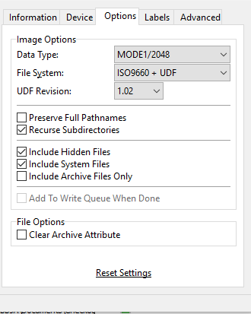

* + 1. Click Labels tab and fill in the Volume Label for both ISO 9660 and UDF
    2. Click Advanced tab
    3. In the Advanced tab click the Restrictions tab
       1. Ensure it is filled out as follows

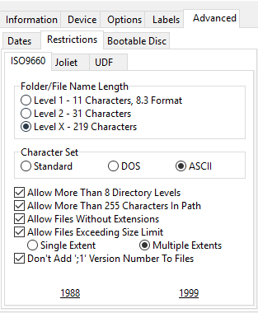

* + 1. In the Advanced tab click the Bootable Disc tab
       1. Clcik the Make Image Bootable check box
       2. Insert the Recovery Disk into the CD Rom drive
       3. In the “Extract Boot Image” are select CD Rom from the drop down and click the disc icon
       4. Navigate to the folder you copied the contents to in step 4a using the window that popped up, select the boot folder in that folder and click save. For my example I created a folder on the desk top and my path is C:\Users\WebbJA\Desktop\Recovery Disk\boot
       5. You will get an “Operation Successfully Completed!” window, click OK
       6. It will ask if you would like to use the boot image file in your current project. Say Yes.
       7. Copy the contents of the folder you created earlier into the Source panel on ImgBurn

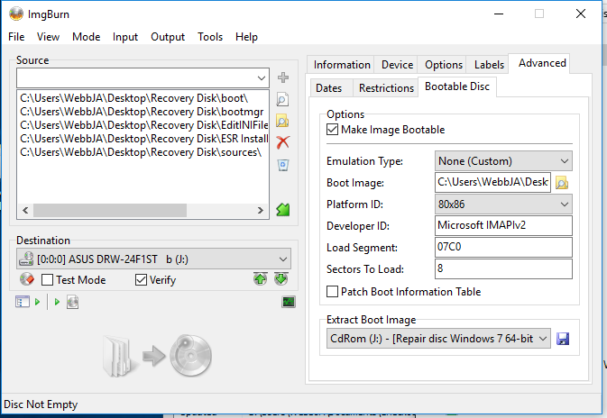

* + - 1. Eject the Recovery Disk and insert a blank disc
      2. When the program is ready to burn the folder, disk and arrow will be highlighted

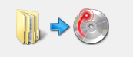

Click there to start the burn

* + - 1. Follow the prompts to finish

1. Update STrP if needed (found in Docs folder of system software)
2. Update SVD (found in Docs folder of system software)
3. Update COTS install if needed (this is in SVN under ATE)
4. Check in changes made to documents to SVN
5. Once you are sure all changes are complete merge branch into trunk.
   1. Right click Trunk choose Tortoise SVN->Merge
   2. Choose “Merge two different trees”
   3. Click Next
   4. From needs to point to the trunk and to points to the branch
   5. Click Next
   6. Test the merge by clicking the “Test Merge” button
      1. If needed fix any issues
   7. Click the “Merge” button
6. Commit the changes to the trunk from the Merge
   1. Right Click SVN Commit
   2. Get the Log history from your branch to add to the Message for the commit
7. Check out the release from the trunk to burn the source disk
   1. I like to check it out to the folder structure as well to verify it will build before creating my Source disk
8. Burn a Source disk for Release
9. Check out the COTS Install to burn a disk
10. Burn a COTS install disk for Release
11. Change the version on the ATLAS subset and create a new release disk for it as well.
    1. Make a new folder on G drive that coincides with the new release version
    2. Make a new disc with the subset on it for Configuration
    3. Create a new folder in SVN to store the new subset
    4. Upload the new subset to the website

A Full Release contains the following:

Source Disk

COTS Install Disk

ESR

ATLAS Subset